Show INFORMATION OF BRAND/MODEL/YEAR of the pre-registered EQUIPMENT when client SELECT the EQUIPMENT in the Open Ticket Form it loads brand, model, year information

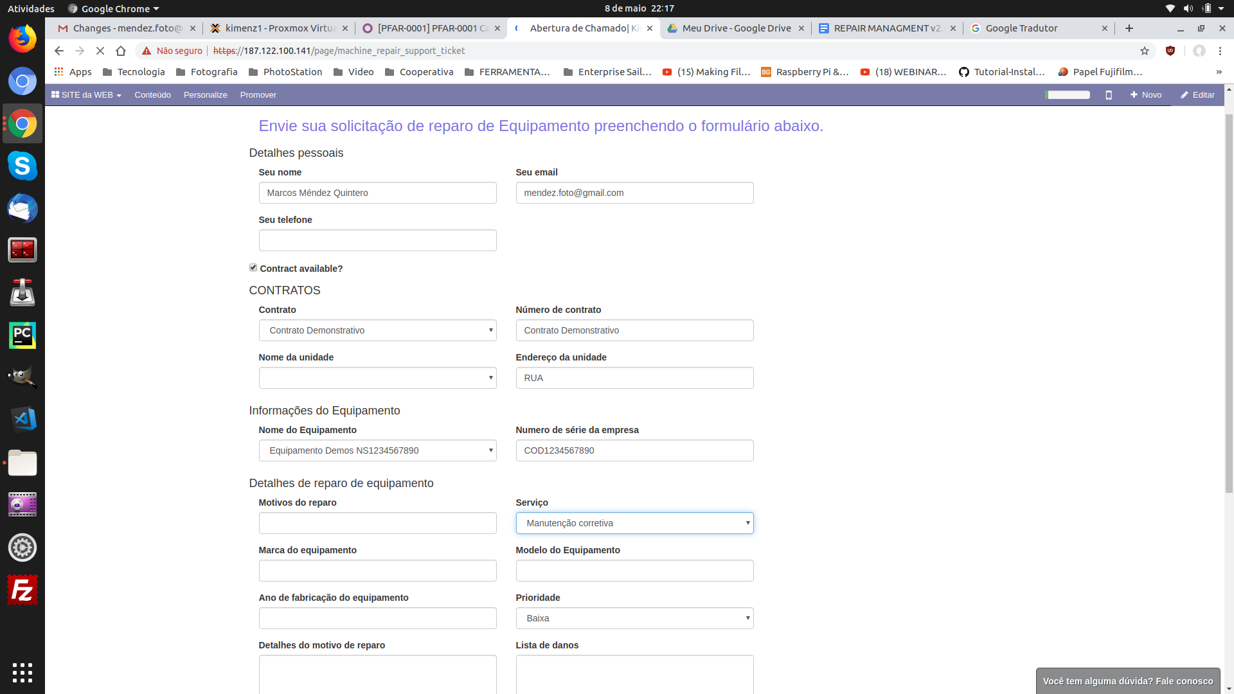

The client can choose between to kind of SERVICEs: REPAIR and BOOKED MAINTENANCE. When choosing BOOKED MAINTANCE (type of service) display a Calendar to provide our client to book the technical visit in the FUTURE it can not be possible to book a maintance to a date that already passed.   
  
Also We will need to show a Calendar with all maintances that the client booked. We need this in the Backend to.

When the client books a maintance estimate a 3 hour service for the technician on each maintance.

In the MY REAPAIRS PAGE (see print screen below)  
  
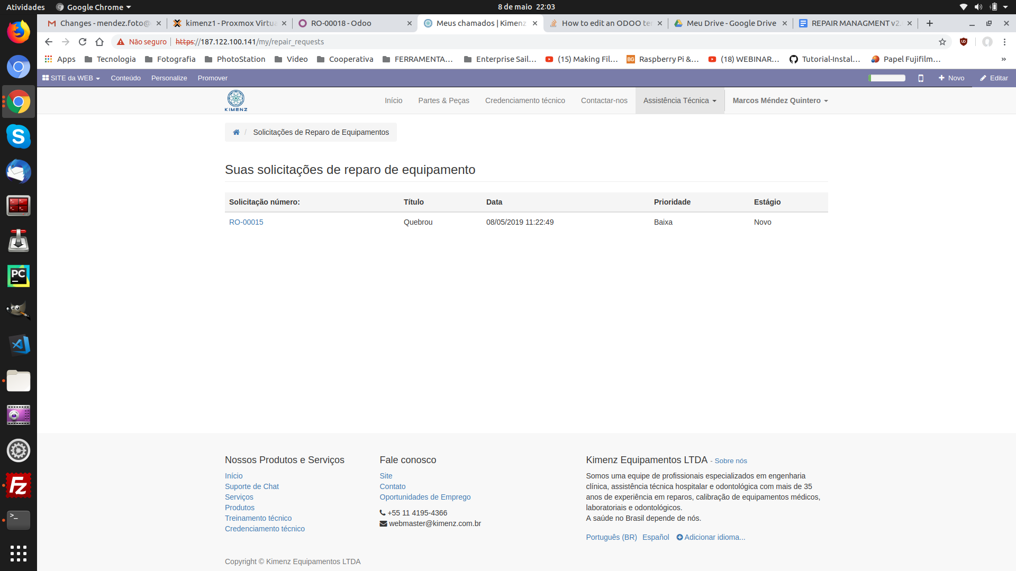

INSERT COLUMN EQUIPMENT NAME   
INSERT COLUMN SN (show equipment BARCODE)  
  
CREATE a DASHBOARD WITH:  
NUMBER OF TICKETS BY LOCATION

NUMBER OF TICKETS BY BRAND  
EXPORT TICKETS REPORTs: TICKETS RE-OPENED

FINALLY  
  
Crea